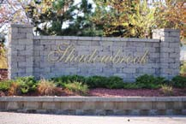
Shadowbrook Homeowners Association

P.O. Box 43773 www.ourshadowbrook.com
Brooklyn Park, MN 55443 ourshadowbrook@gmail.com

March 13, 2015

Dear Shadowbrook Homeowner,

This letter is to inform of a recent change to our accounting practice for the Association. During our annual meeting held on January 12, 2015, it was voted on and approved to hire an external accountant to manage the Association. Smith Accounting Service was hired to handle the financial management of our Association, including collecting of annual dues and processing of delinquent accounts.

Enclosed are current statements for your account. Payment should be sent in the enclosed envelope directly to Smith Accounting Service (address below). Checks should still be made out to Shadowbrook Homeowners Association. Yearly dues are due within net 60 of the invoice date. The 2015 dues must be paid and postmarked by May 1st, 2015 to avoid a $100.00 late fee. If your account has previous year’s dues open, those must be paid by March 20, 2015 to avoid a $100.00 late fee and further processing of your account.

If you have any questions regarding dues or the financial accounting for the Association, please don’t hesitate to contact one of your board members listed below or Dan Smith or Sandy Danks with Smith Accounting Service at 952-473-0395. The fax for Smith Accounting Service is 952-473-0296. Sandy Danks can also be reached by email address sandy@smith-accounting.us.

Regards,
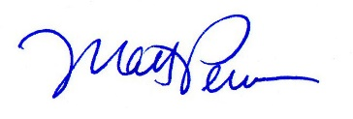
Matt Perron
Treasurer
Shadowbrook Homeowners Association
www.ourshadowbrook.com
ourshadowbrook@gmail.com
matt.perron@comcast.net

Other Board Members:

Jeff Thompson Jason Hill
President Secretary
Jeffreym44@gmail.com Jashil@comcast.net

Checks should be mailed to:

Shadowbrook HOA
c/o Smith Accounting Services
840 Lake Street E, Suite 200
Wayzata, MN 55391

